PLUGGING INTO THE FUTURE: AN EXPLORATION OF ELECTRICITY CONSUMPTION PATTERNS

1. INTRODUCTION

Whereas electricity consumption represents the amount of electrical energy that has been consumed over a specific time, in units of WH or KWH, electricity demand represents that rate at which electrical energy is consumed for a needed output rating, in units of W or KW.

*2. PROBLEM DEFINATION & DESIGN THINKING*

The environmental problems directly related to energy production and consumption include air pollution, climate change, water pollution, thermal pollution, and solid, waste disposal. The emission consumption indicates sustained momentum of economic activities in December.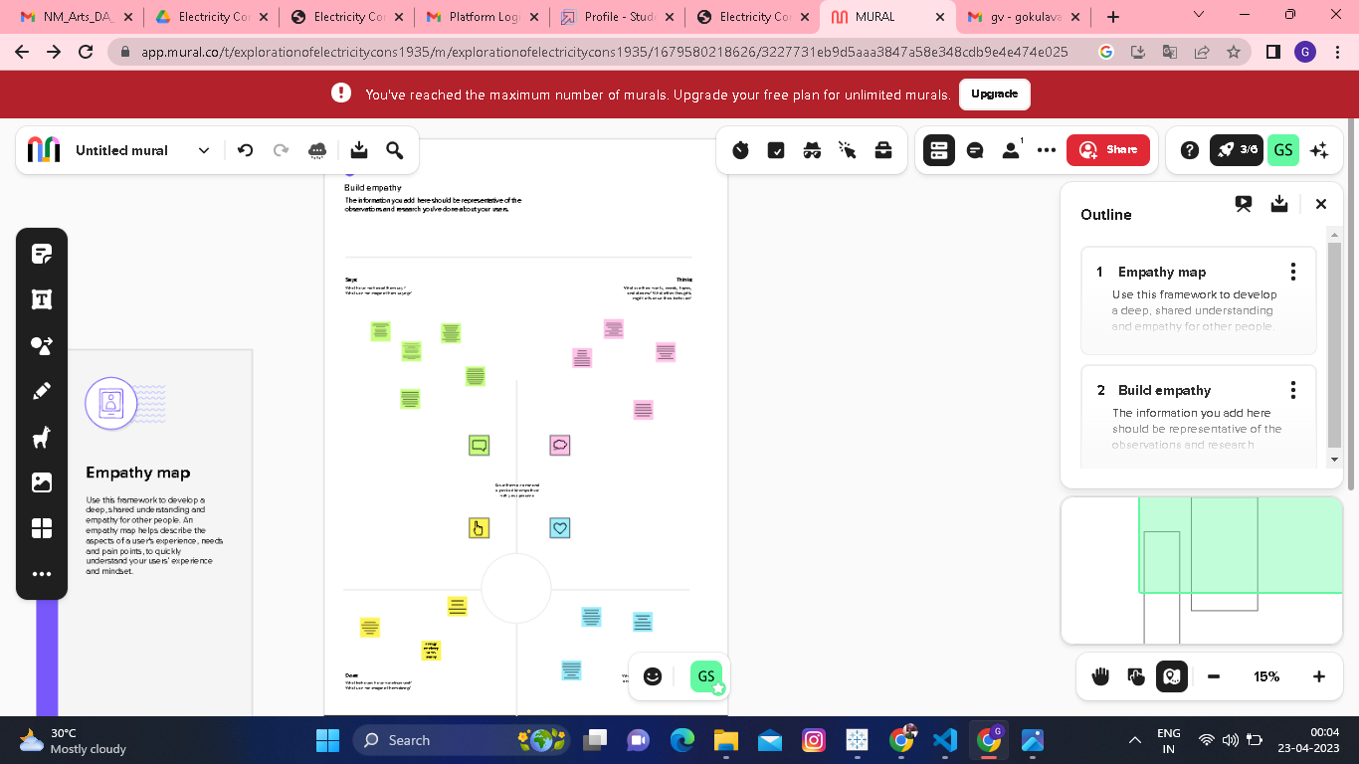 RESULT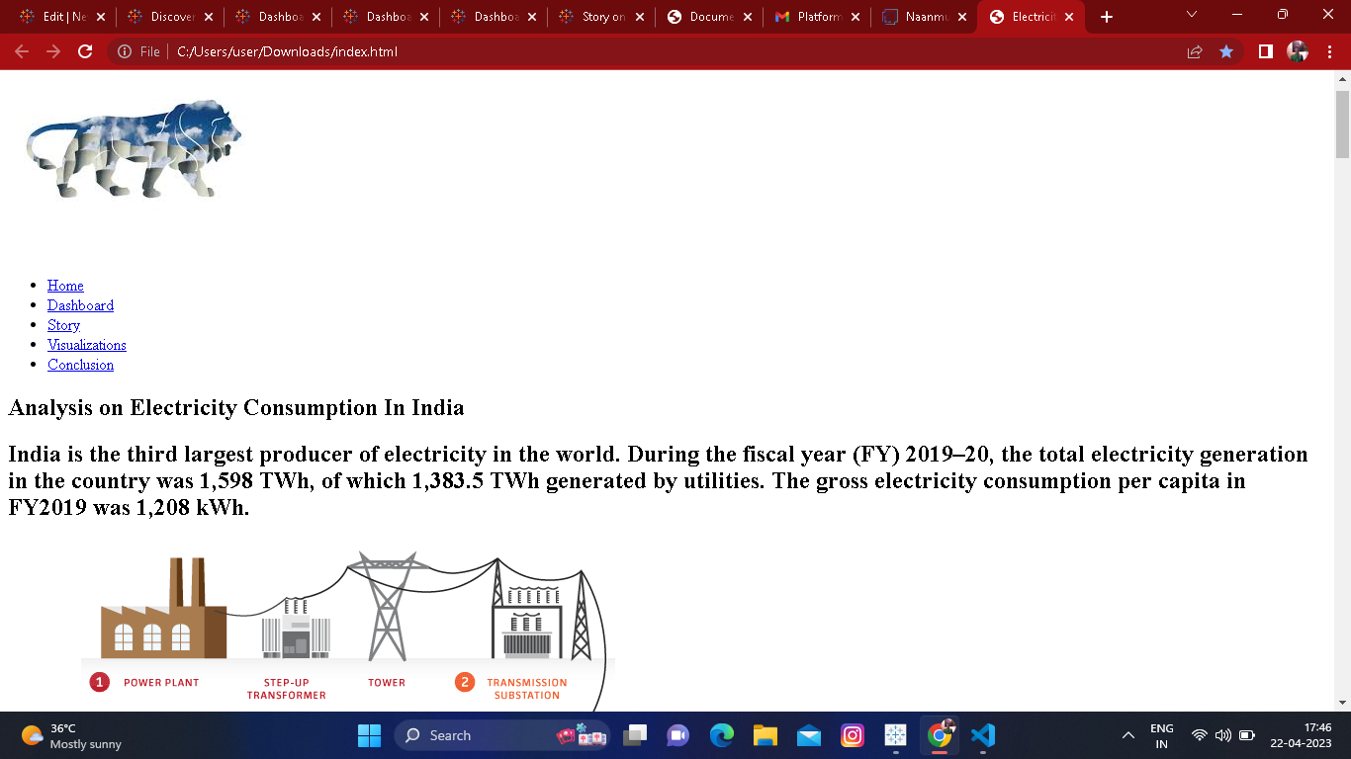

* RESULT: 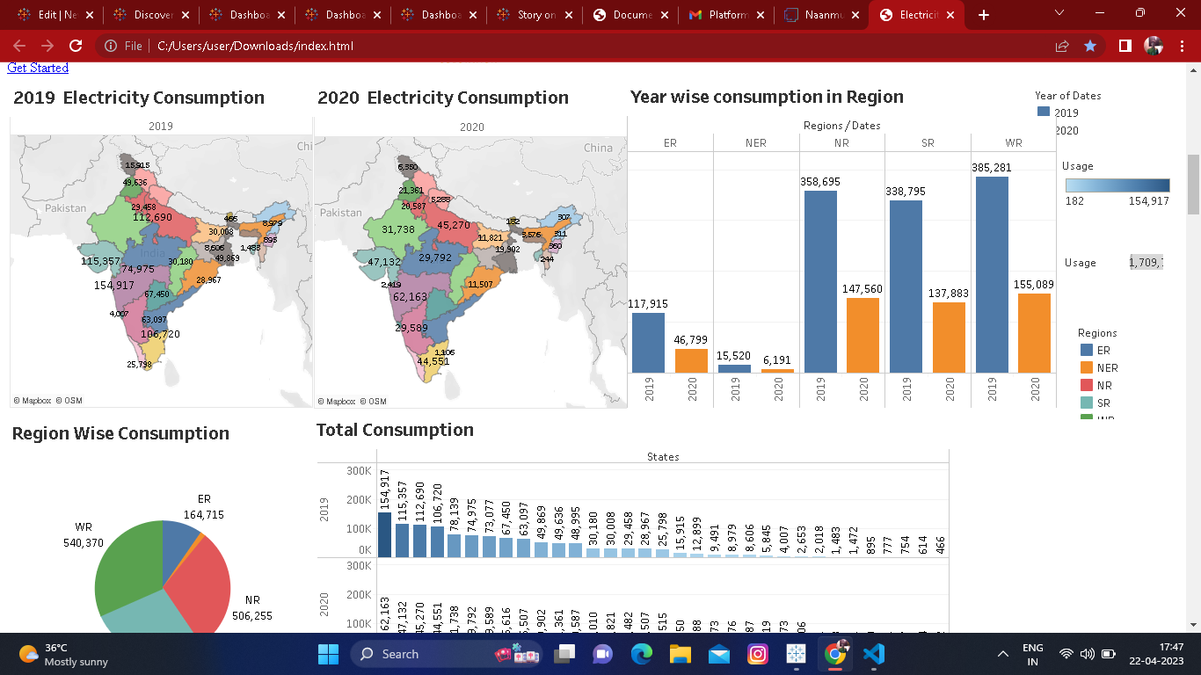 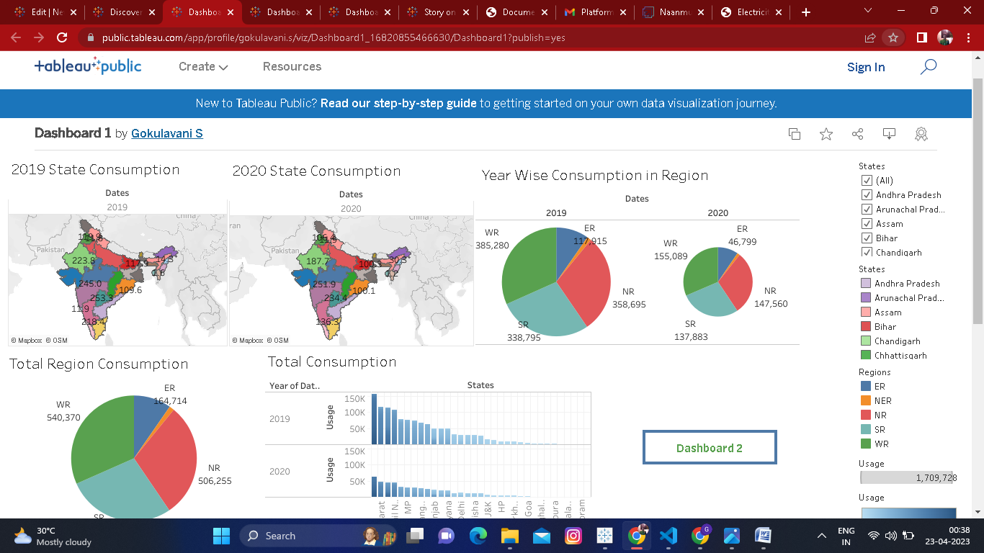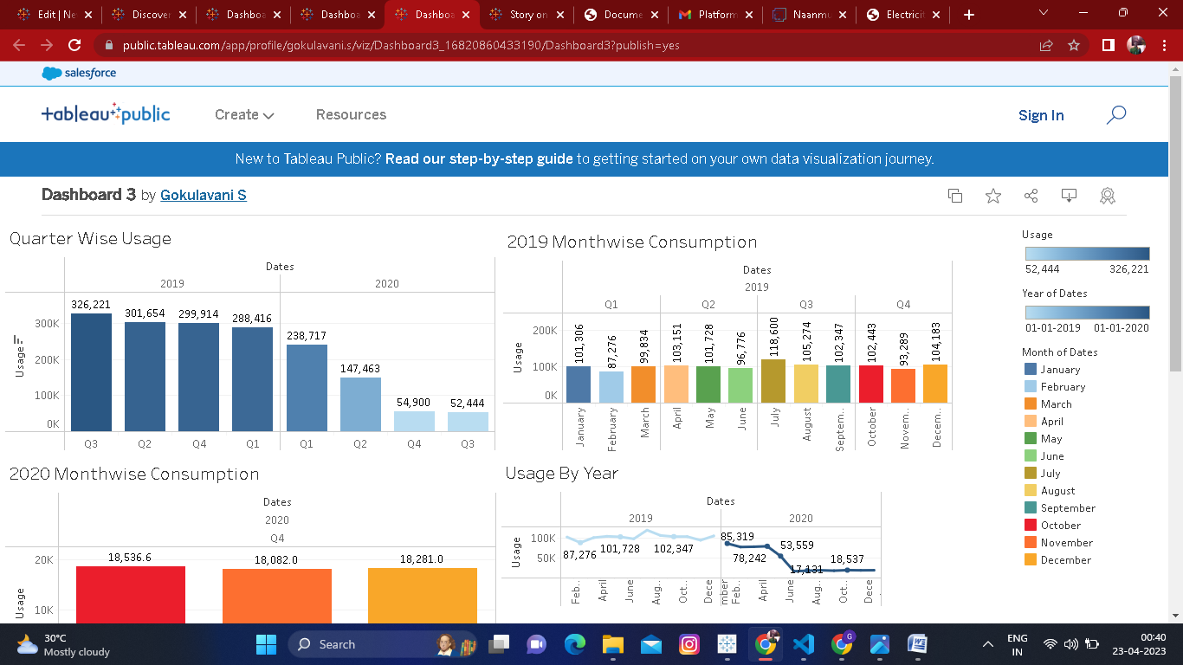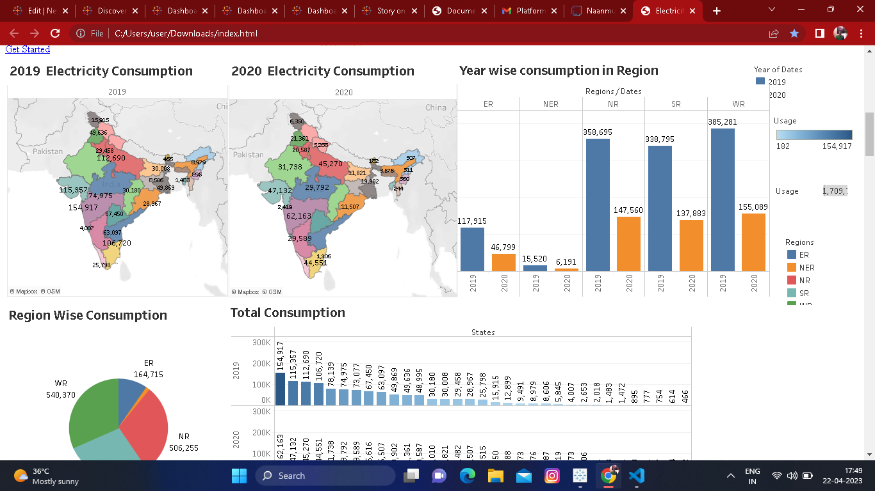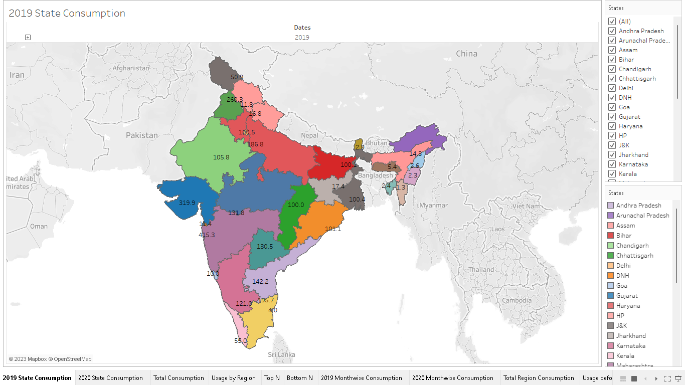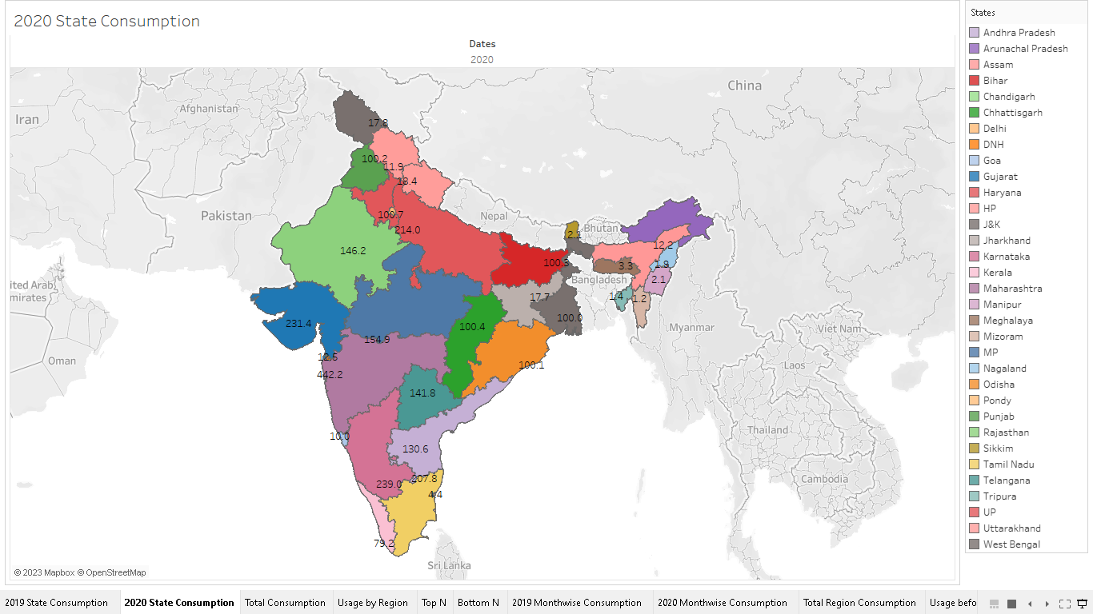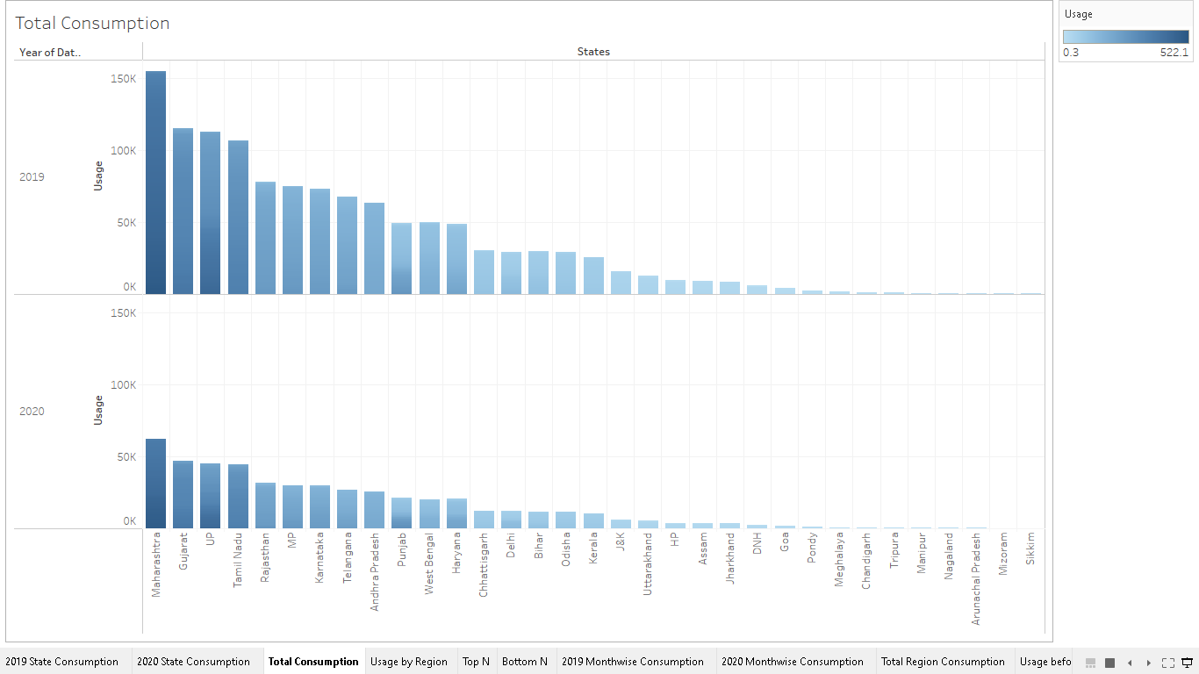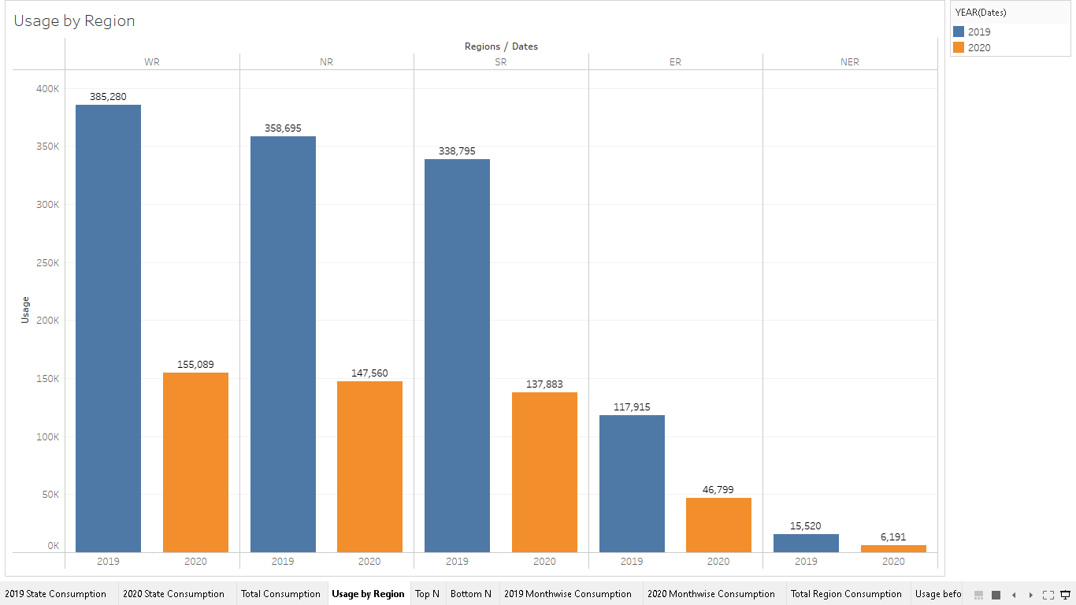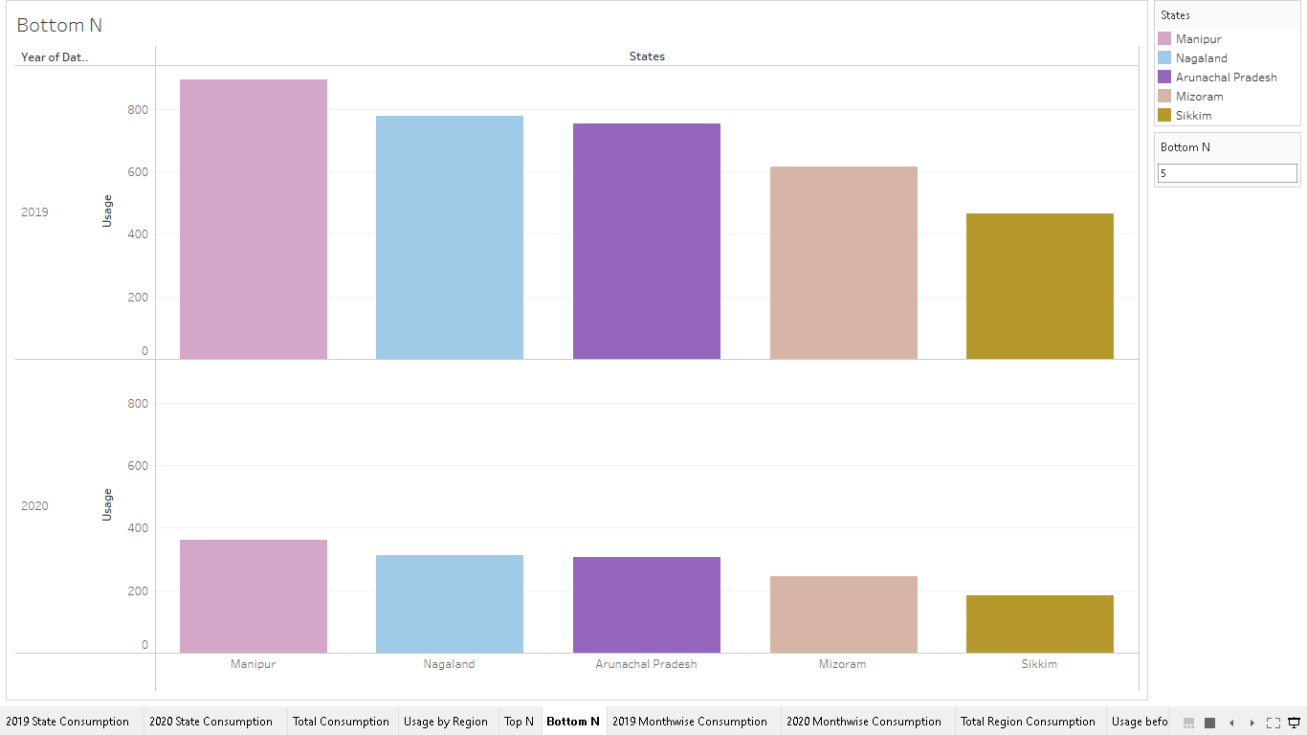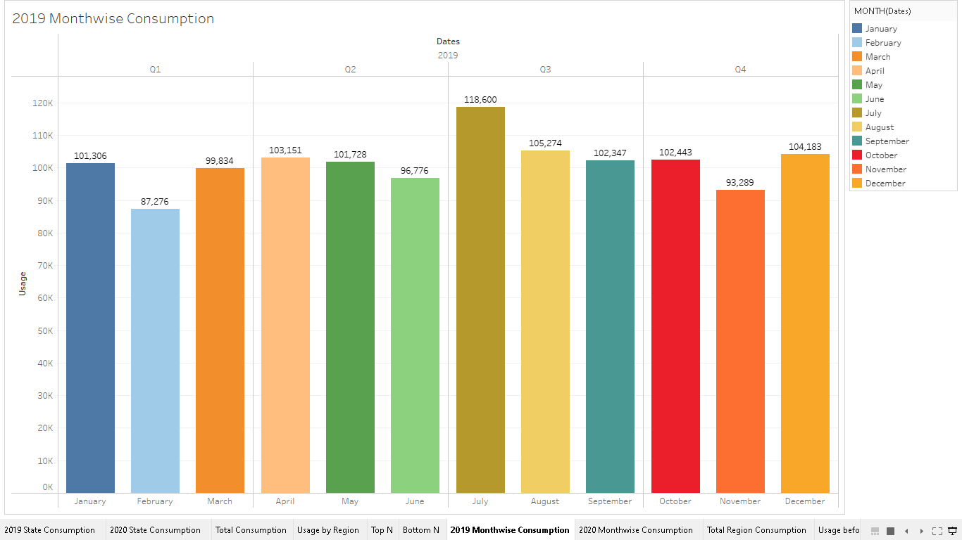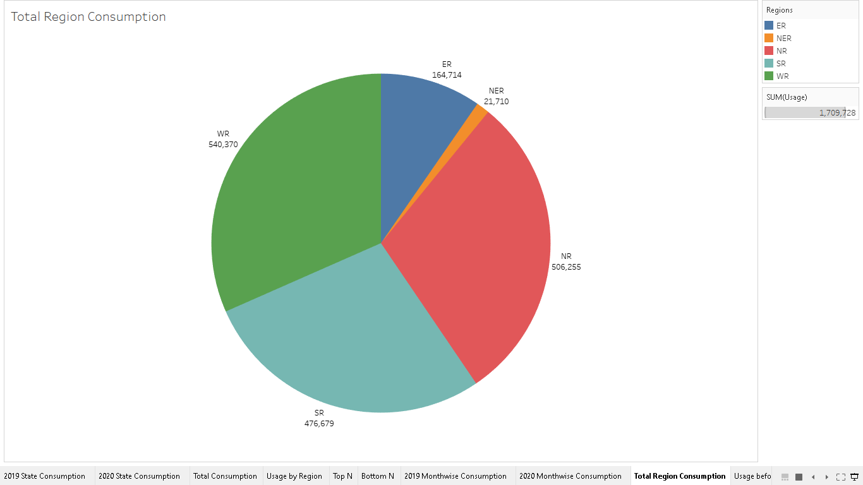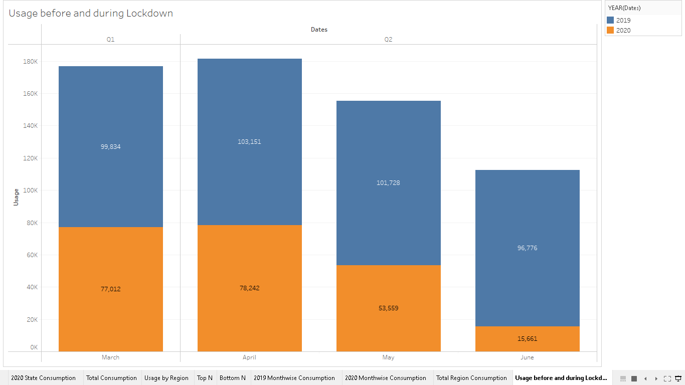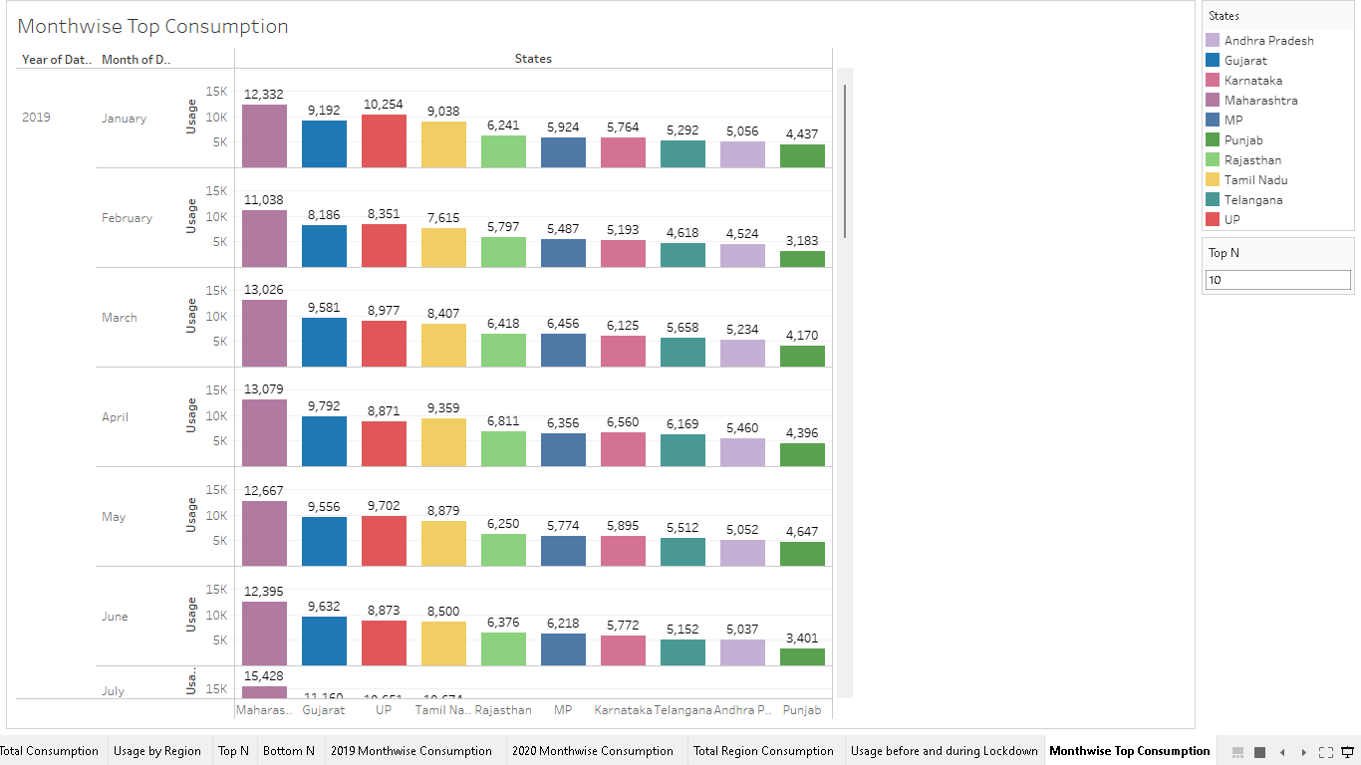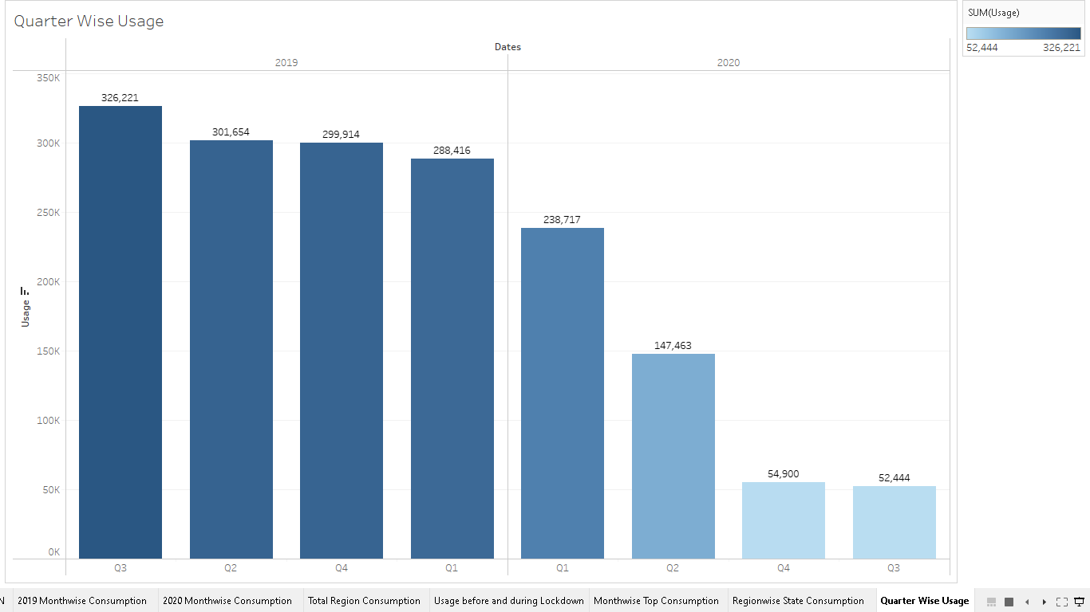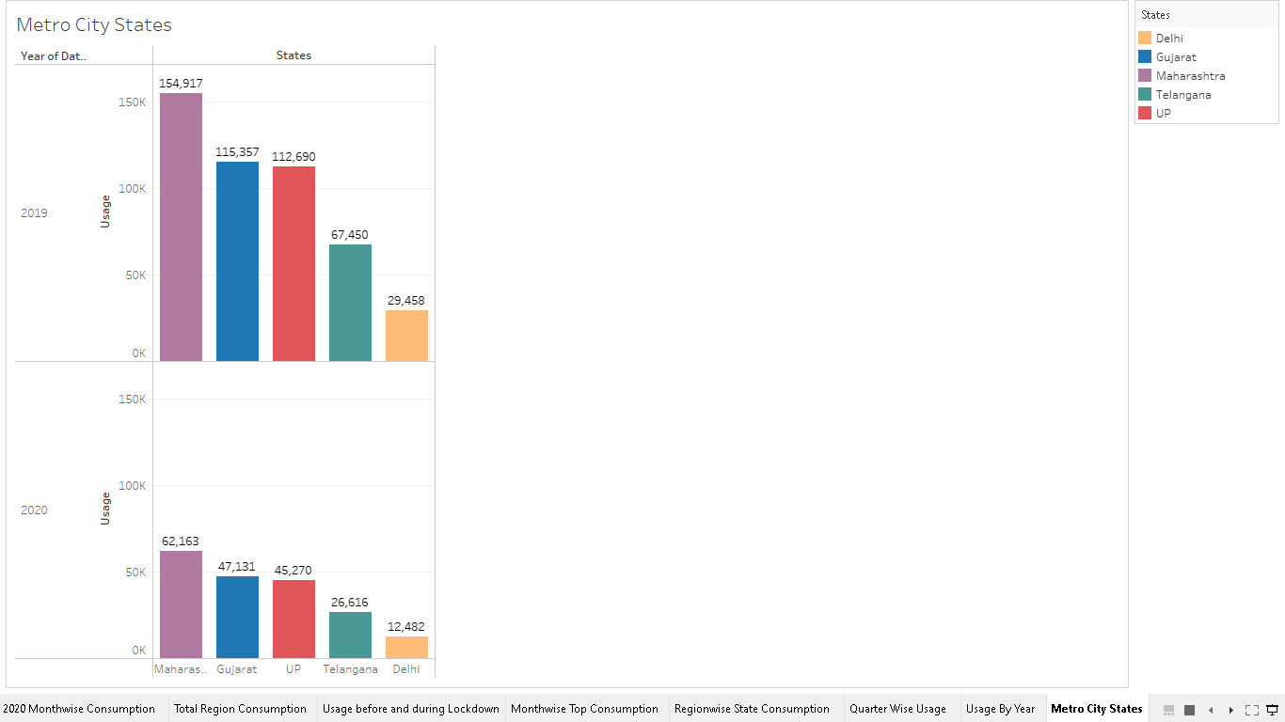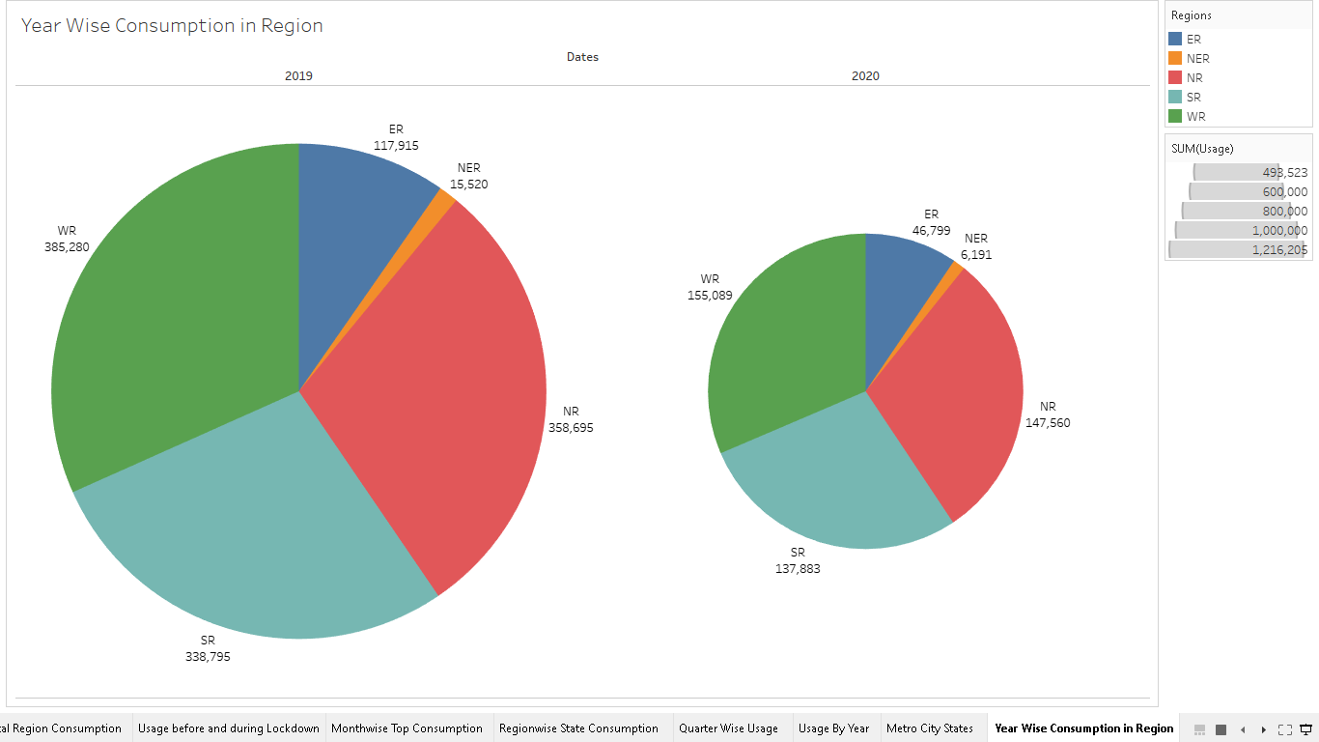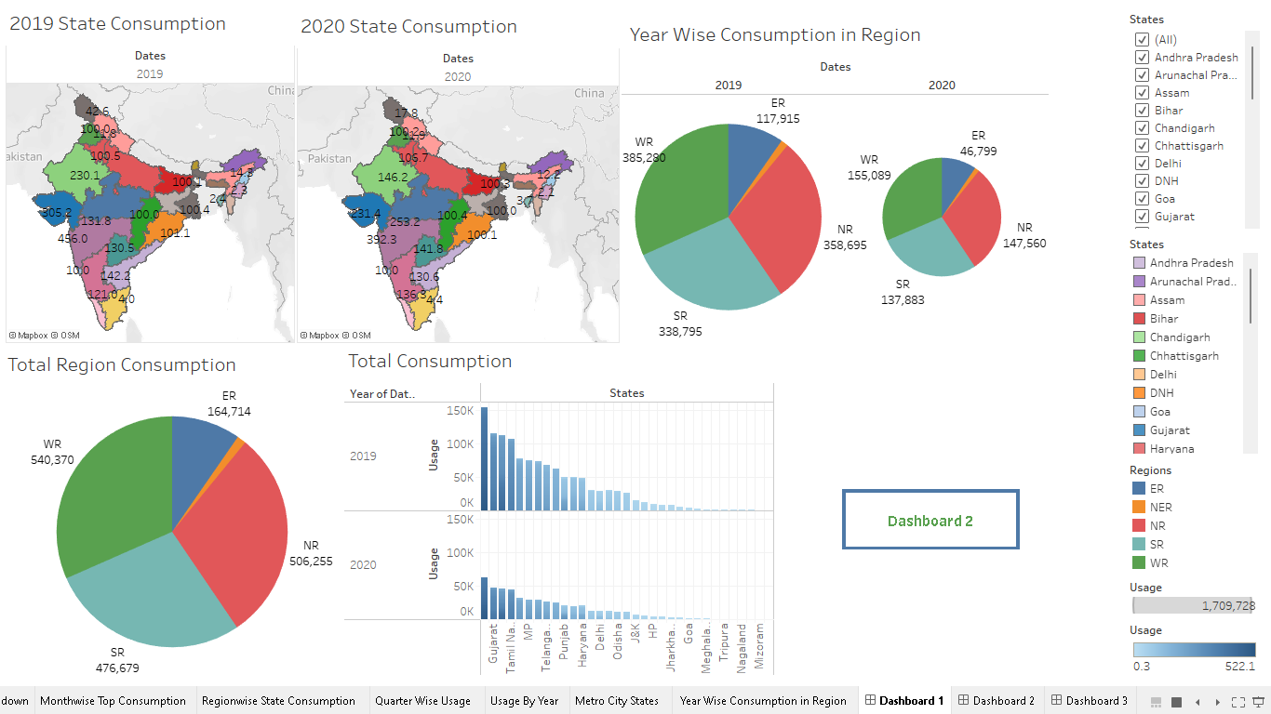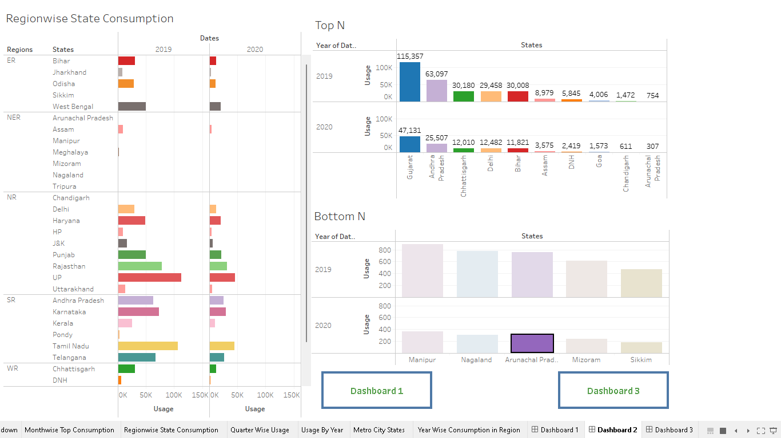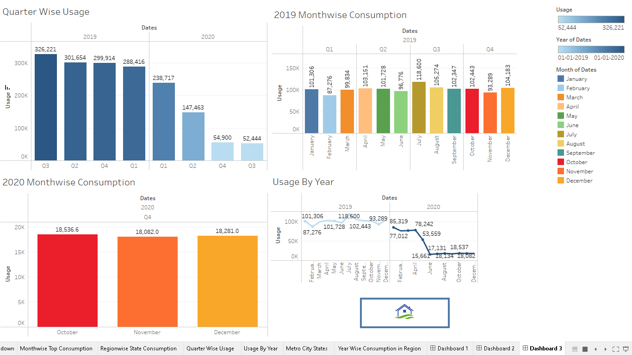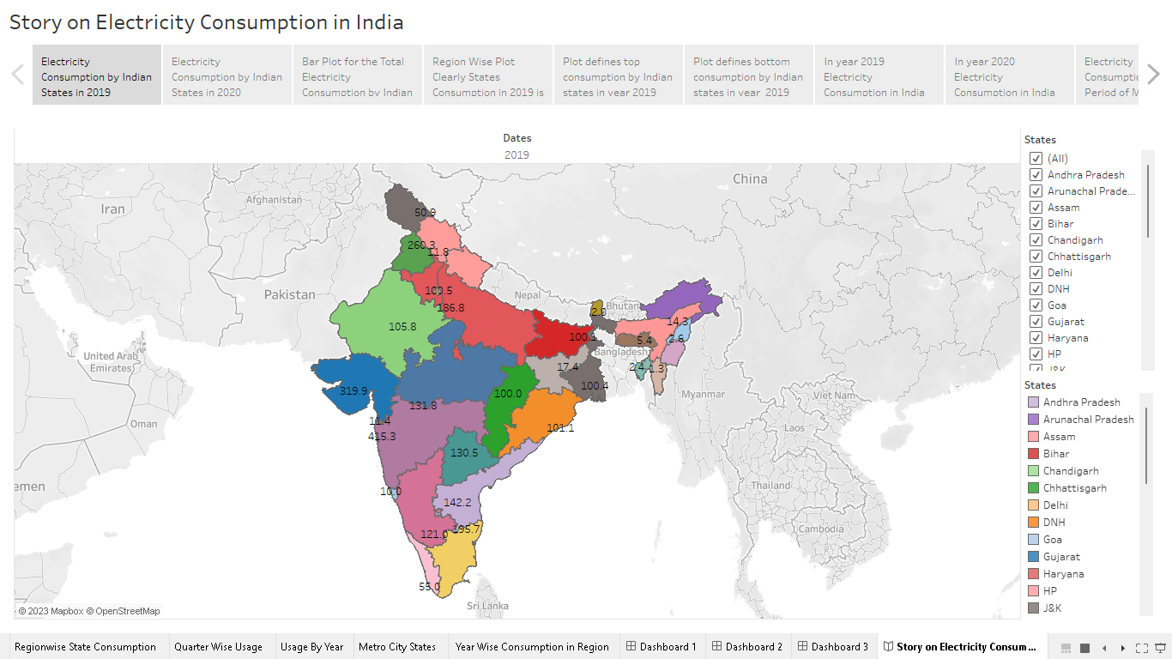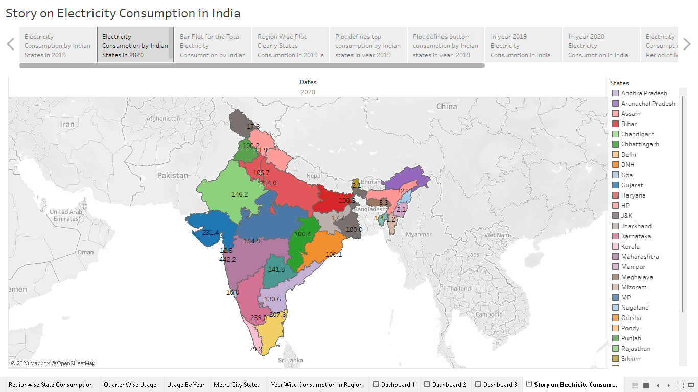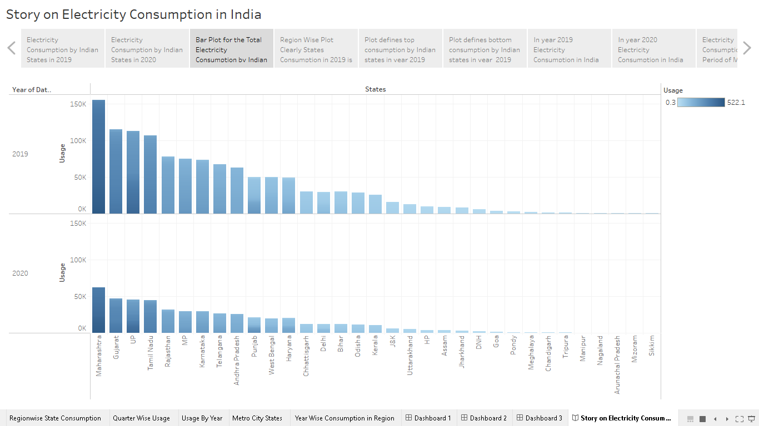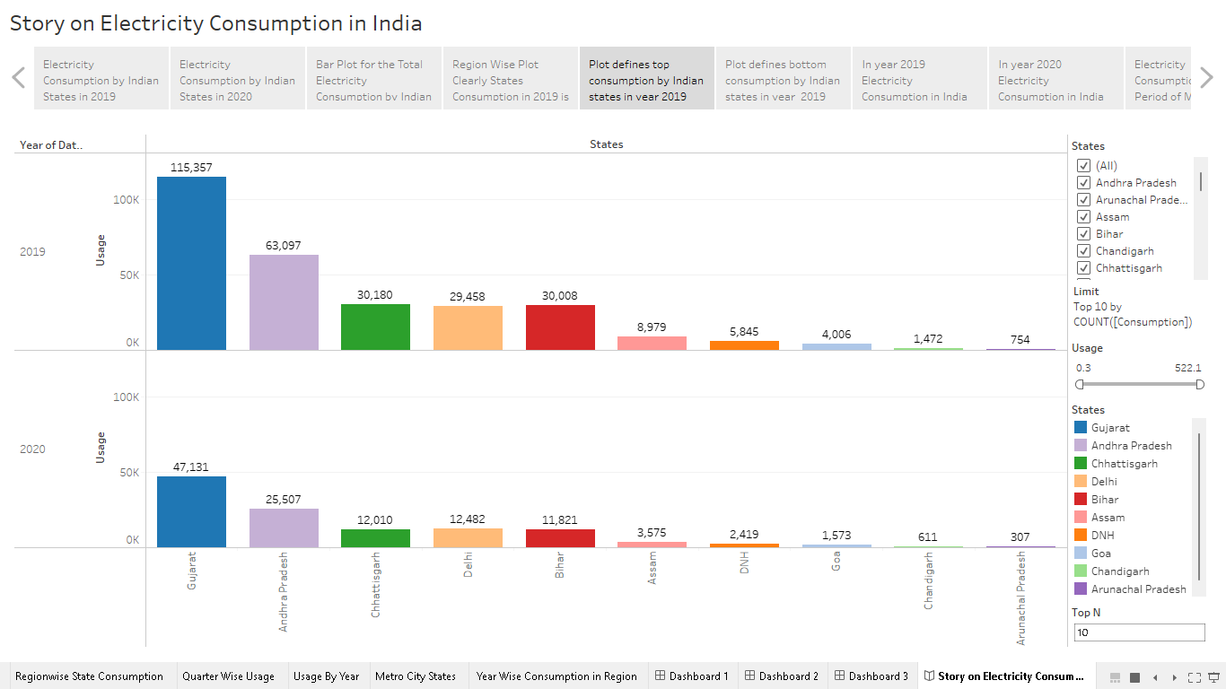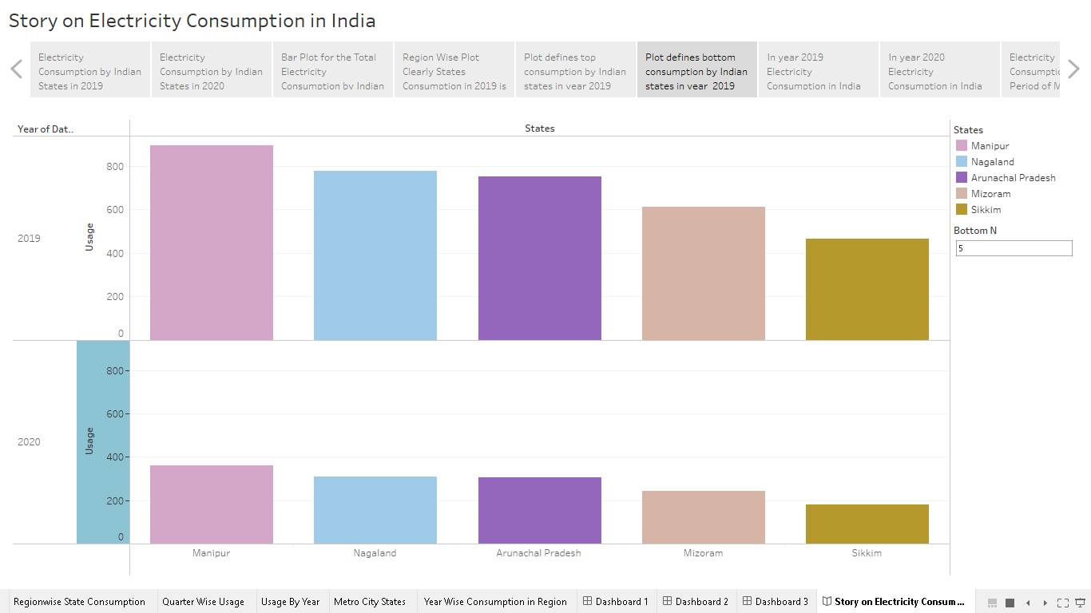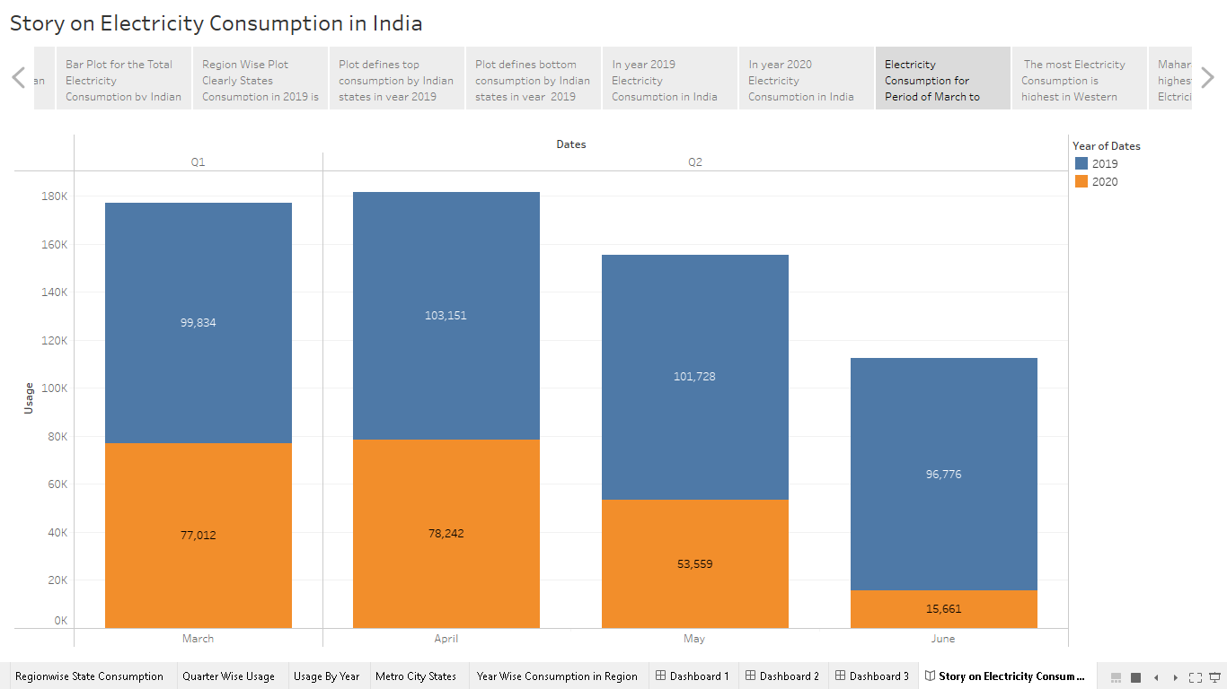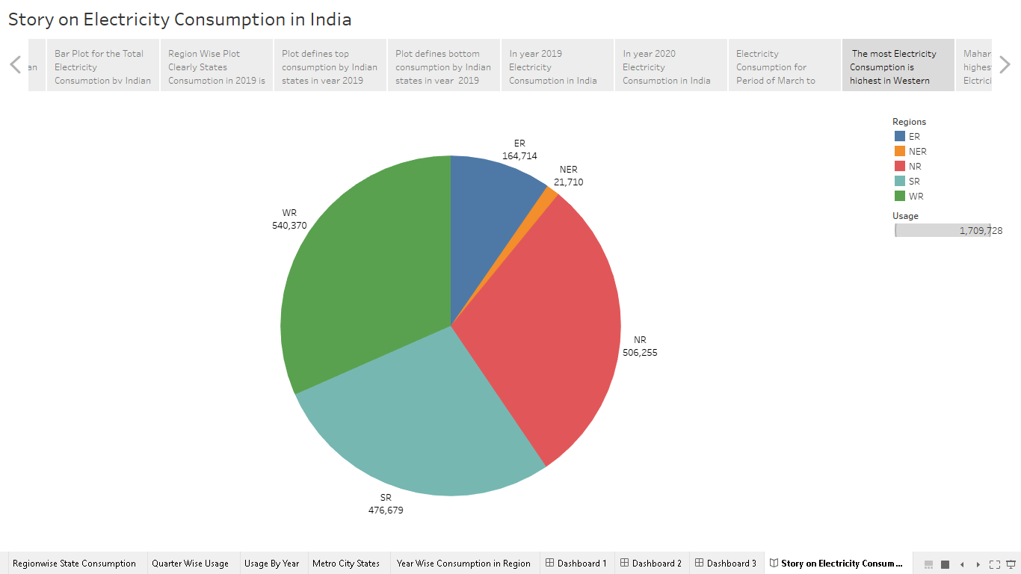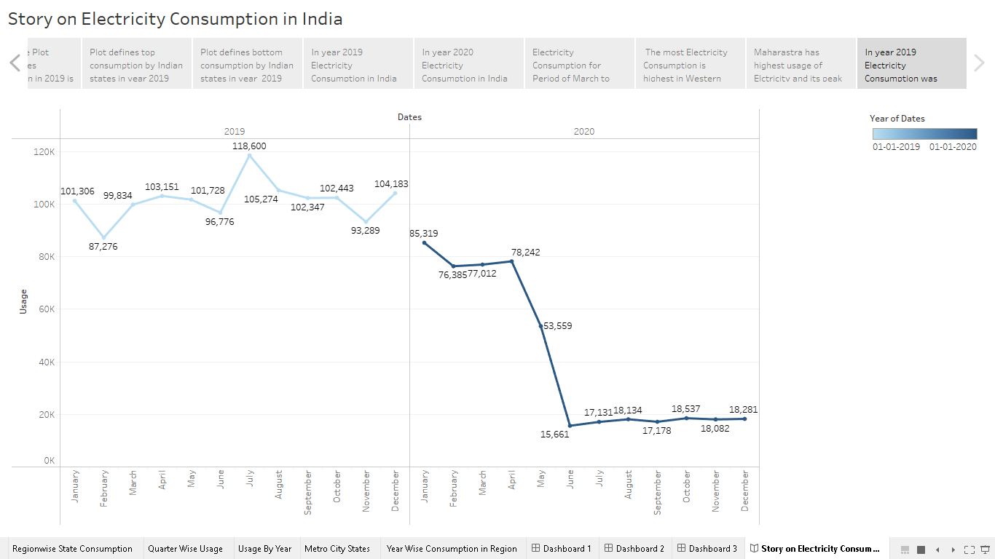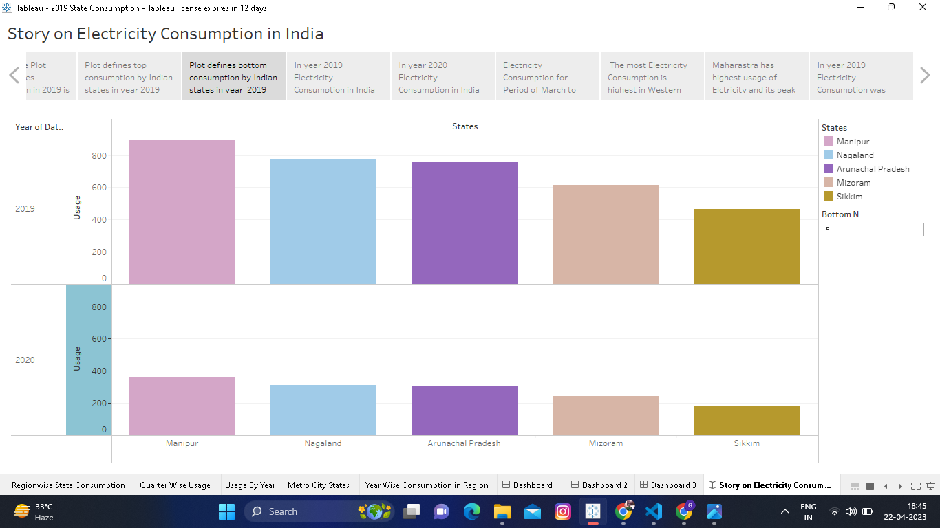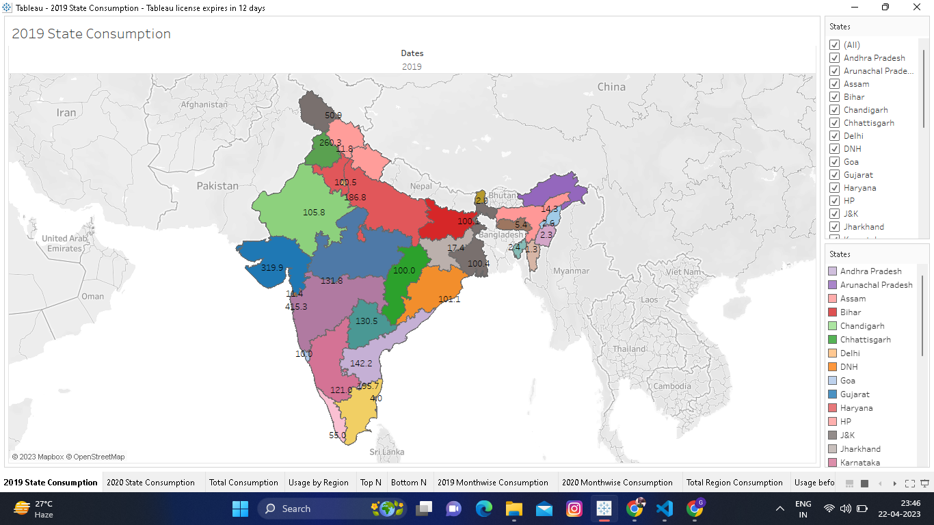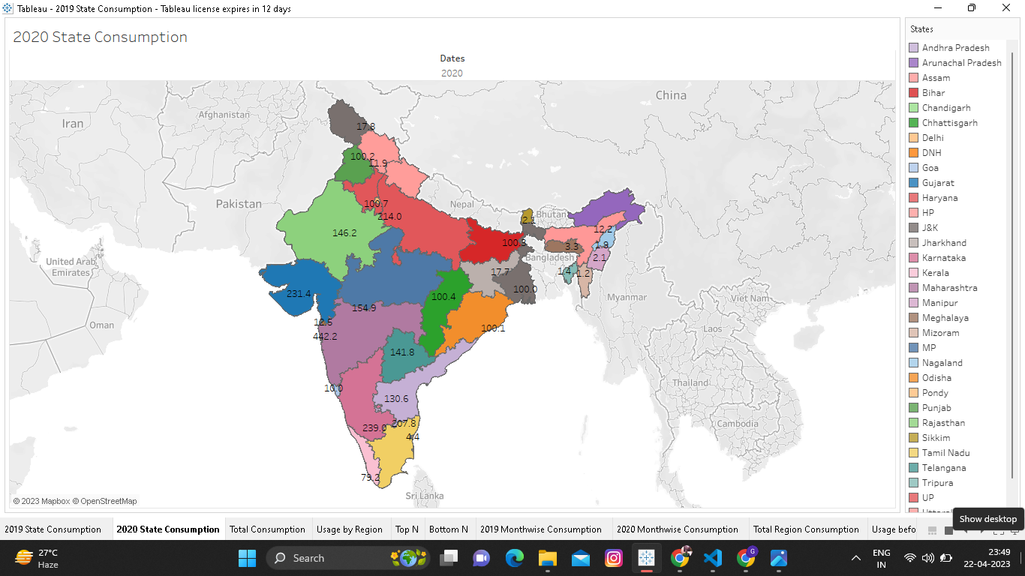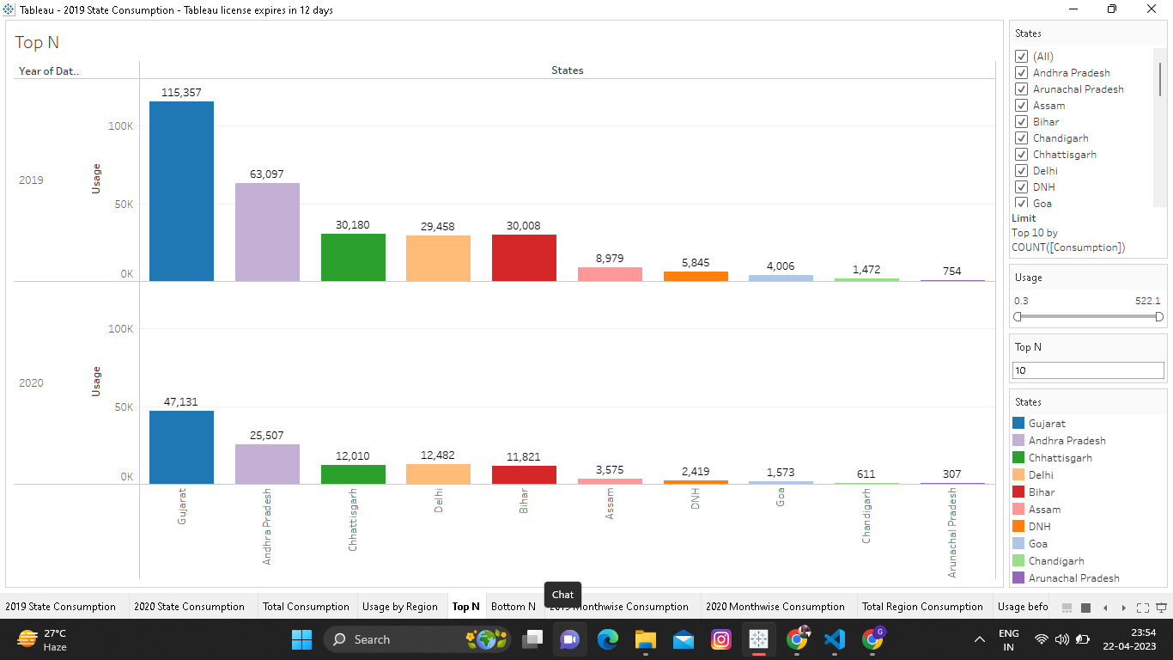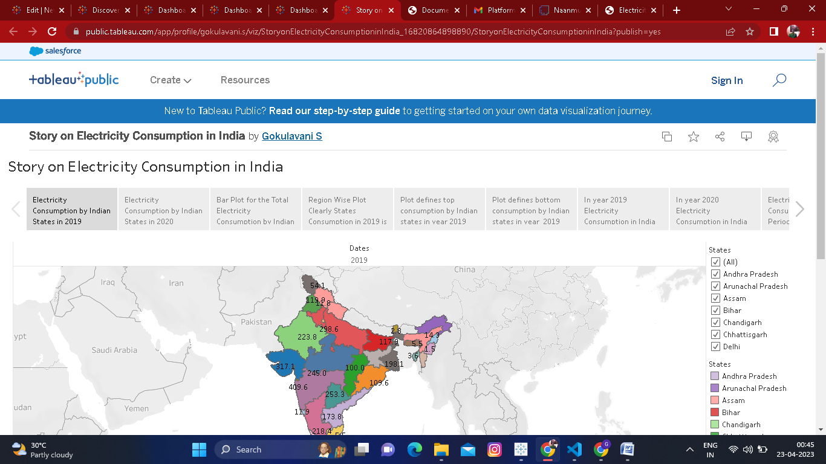

ADVANTAGES AND DISADVANTAGES

ADVANTAGES:

* Lower electricity bill
* Environmental will be safe
* Energy efficiency saves money,, increases the and reliability of the electric grid and provides environmental, community and health benefits.

DISADVANTAGES:

* Man power will be decreases
* It is due to unexpected blasting causes many death
* Electricity cannot be transported in hill station

APPLICATIONS

* Chilled beam
* Electric train
* Electric vehicles
* Net zero energy building
* Solar energy
* Bio energy
* Thermal energy
* Coal
* Wind energy
* Water energy

Conclusion

Here we create a lot of ideas and new invention. In future all will come electricity energy so we are get ready for that. And we are attached the some files like empathy map, brainstorming, sheet of consumption and dashboard 1,2,3. And story and tableau public upload dashboard and story and some file.

FUTURE SCOPE

Manufacturing industries that employ electrical engineers include auto motive, marine, railroad, aerospace, defense, consumer electronics, commercial construction, light, computers and component, telecommunication and traffic control.